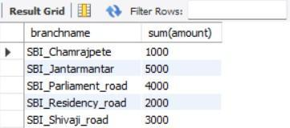

## **More Queries on Bank Database**

### **Question (Week 4)**

* Branch (branch-name: String, branch-city: String, assets: real)
* BankAccount(accno: int, branch-name: String, balance: real)
* BankCustomer (customer-name: String, customer-street: String, customer-city: String) **-** Depositer(customer-name: String, accno: int)
* LOAN (loan-number: int, branch-name: String, amount: real)
* Find all the customers who have an account at all the branches
* located in a specific city (Ex. Delhi).
* Find all customers who have a loan at the bank but do not have an account. - Find all customers who have both an account and a loan at the Bangalore branch
* Find the names of all branches that have greater assets than all branches located in Bangalore.
* Demonstrate how you delete all account tuples at every branch located in a specific city (Ex. Bombay).
* Update the Balance of all accounts by 5%

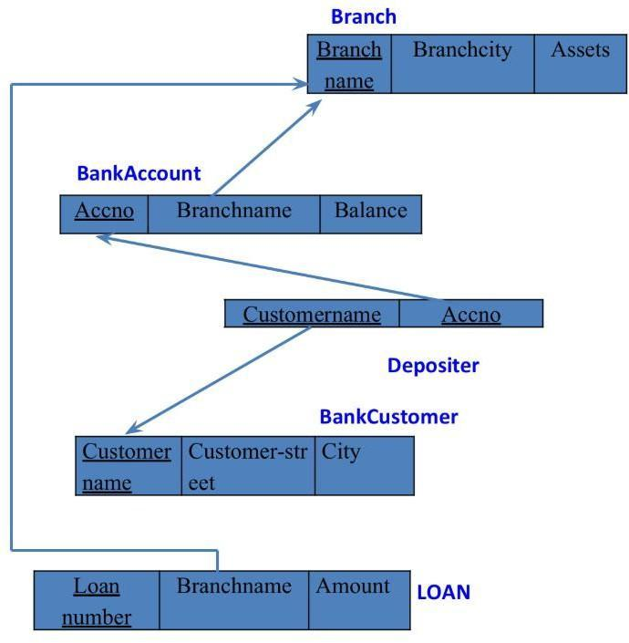

### **Queries**

###### **Find all the customers who have an account at all the branches located in a specific city (Ex. Delhi).**

**select** d.customername **from** depositer d, Branch b, Bankaccount a

**where** b.branchname = a.branchname and a.accno=d.accno and city = 'Delhi'

**group by** d.customername having **count(**distinct b.branchname)=(select count(branchname) from Branch

**where** city = 'Delhi');

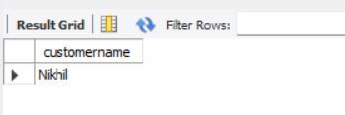

###### **Find all customers who have a loan at the bank but do not have an account.**

**select distinct** d.customername from depositer d, Bankaccount ba, Branch b where d.accno = ba.accno And ba.branchname=b.branchname and b.city='Delhi' group by d.customername **having count**(distinct b.branchname)>1;

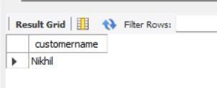

###### **Find all customers who have both an account and a loan at the Bangalore branch.**

**select** b.customername from Borrower b **where** b.loannumber in(select d.accno **from** depositer d, Bankaccount ba, Branch b **where** b.loannumber = d.accno and d.accno = ba.accno and ba.branchname=b.branchname and b.city='Bangalore');

